PlayBlackJack Welcome Email

Recommendations:

Content

Subject line does not contain the offer and has Blackjack, which is a hot word for Spam Filters

Some suggestions:

- Hi [Name], your account is ready, here is your bonus
- Important information about your welcome bonus
- Hi [Name], here is your bonus

Pre-header text not properly formatted
The div does not included any color information, so white text on white background is not displayed:

Add the color spec to allow the full sentence to be displayed:

Offer:

Make offer more prominent and include clear CTA

- Offer is not prominently featured, only at the bottom of the mail
- Offer is only displayed in an image, so will not be visible when images are not displayed. “Images blocked” is default in almost all email clients. Add the offer in text as well, so that player can view it with blocked images
- The main call to action section is not very compelling
---

"Get A 200% Bonus On Your First Deposit"
1. Log in to your account (your user name is {login})
2. Click "Cashier" in the menu bar
3. Deposit with your favorite method
4. Start playing your favorite kind of 21

---

Since the action you would like me to take is to log in and play, there should be a button/CTA to that effect – ‘Play Now’ or ‘Log In’

Explain how the bonuses work
- The email and website both tell me that I will get a bonus, but neither explains how the bonus will actually be awarded to me or what, if anything I need to do to get the bonus
- Include support icons - Email and Live Chat to let me know that I can contact support in order to get my bonus
- The page being linked to does not clearly outline the rules applicable to my bonus – rollover is not stated, only an example given. Withdrawal/ country/ etc restrictions not included on the page

Different bonuses on browser and mobile sites
When I checked the email from a mobile browser and clicked a link, I was showed a 121% bonus, and not the 200% bonus that is included in the email and advertised on the website (desktop version).

Create whitelisting page
- Many players don't know how to add you to their contacts list. Building a page with instructions for how to whitelist is a good way to educate them.
- Also, you should tell me which email address to add; since your mail is coming from playblackjack@reply.bronto.com - is this the address you want me to add? Does all marketing communication come from this address?

Include trust cue in mail: Accepted Deposit method
- Add accepted deposit methods in the email and link to the cashier
- Support icons will also act as trust cues

Include a signature at the bottom of the mail
- Makes mail seem more personal/ human
- Allows you to include all contact details in text format (right now phone number is not visible unless images are unblocked)

e.g.

[First Name] [Last Name]
Customer Support Manager
1-888-815-5874
support@playblackjack.com

Other:

- In the opening paragraph, the period after PlayBlackJack.com is in red, not sure if this is intentional
- Alt text is not formatted, so doesn’t display well in some email clients. Can be formatted with a <font> tag before the image
- Remove un-needed alt text eg ‘Promo box line’ as it makes mail look cluttered.
- Alt text mentions ‘Black Jack’ instead of ‘Blackjack’

General observation:
The playblackjack.com website has a lot of color thanks to the games and offers. This email is very ‘flat’ and doesn’t have the same vibrant look as the website. Perhaps adding some game images would brighten up the look of the mail.

Technical

Email Authentication
- Mails should be signed with SPF and DKIM to improve email deliverability. Yahoo and Outlook (Hotmail) use these to filter spam, no signature means that mail is more likely to get blocked
- Avoid large volume spikes – email will get blocked if it is an unexpected spike. You should try and build volume gradually.
- Sender score in the graph below drops when volume spikes, which means mail is not accepted by IPS.

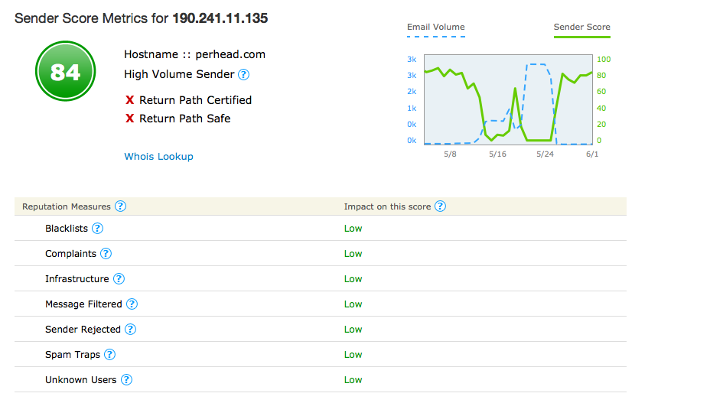
- WHOIS Lookup is open – lists a ‘Rafael Chaves’ as the registrant. You might want to mask that.
- Sending domain is linked to perhead.com and prolexic.com, so if Playblackjack.com is flagged for spam, these two domains might be compromised for being ‘guilty by association’

Reduce Spam wording
- ‘Blackjack’ is a hot word for spam filters, and usage should be limited. Blackjack appears 5x in the content and 15x in the alt tags
- Other words to look out for a ‘deposit’ , ‘bonus’, ‘cashier’ – these can be used but should be used sparingly. $ and % symbols will also trip filters. Use synonyms such as ‘bucks,’ ‘dollars’ or USD in the content

Materials linked to main domain
- If the email is marked as Spam, the images will be linked to the main domain, which can result in the domain being blacklisted and possibly blocked by your ISP/ Hosting provider.
- Suggestion is to either have Bronto host these for you, or host them somewhere else
- Also recommend having a separate domain for support eg support@pbjsupport.com, so that no complaints are linked to the main site.

Fix broken links/ Add links #
- "1) Log in" should be linked to the site/ log in page
- The ‘Unsubscribe’ and ‘Forward to a friend’ links are not working in the Welcome email footer. This could be a Bronto issue
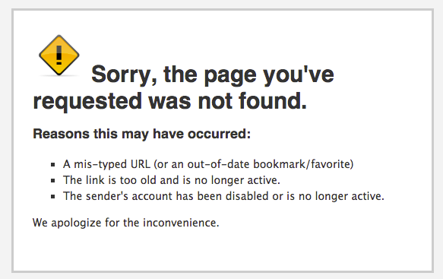
- The image containing the email address is not linked to send an email, should be linked to mailto:support@playblackjack.com

Other:
- Mail uses short-hand hex values in some places #FFF vs #FFFFFF; some email clients will ignore the color if long hand is not used

